## RESEARCH PAPER

## AI Legal Assistance for Contracts & Compliance

## Authors: Code Rangers

## Date: [July 10, 2025 - July 30, 2025]

**Roles & Responsibility –**

1. **Digvijay Thakur –** Designed and implemented the user interface of the application.
2. **Jay Umap –** Developed APIs, integrated AI models, and managed server logic.
3. **Pradyum Patwari –** Assisted in UI design, responsiveness, and frontend debugging.
4. **Om Gandharwar –** Lead problem analysis, project research, and solution brainstorming

**Contact: Digvijay Thakur - +91 83299 65306**

## 1. Abstract –

* This research explores the use of Artificial Intelligence (AI) to assist non-lawyers in understanding legal contracts by identifying risky clauses and summarizing content in plain language. The proposed AI solution addresses a real-world gap by enabling users to review contracts efficiently, affordably, and securely without legal expertise.

## 2. Introduction –

* Contracts form the foundation of modern transactions—from food delivery to job offers and rentals. However, many individuals struggle to understand the legal jargon within contracts, leading to potential legal and financial risks.
* Our AI-powered platform aims to democratize access to legal understanding and promote safe contract compliance for everyday users.

## 3. Motive, Aim, and Vision –

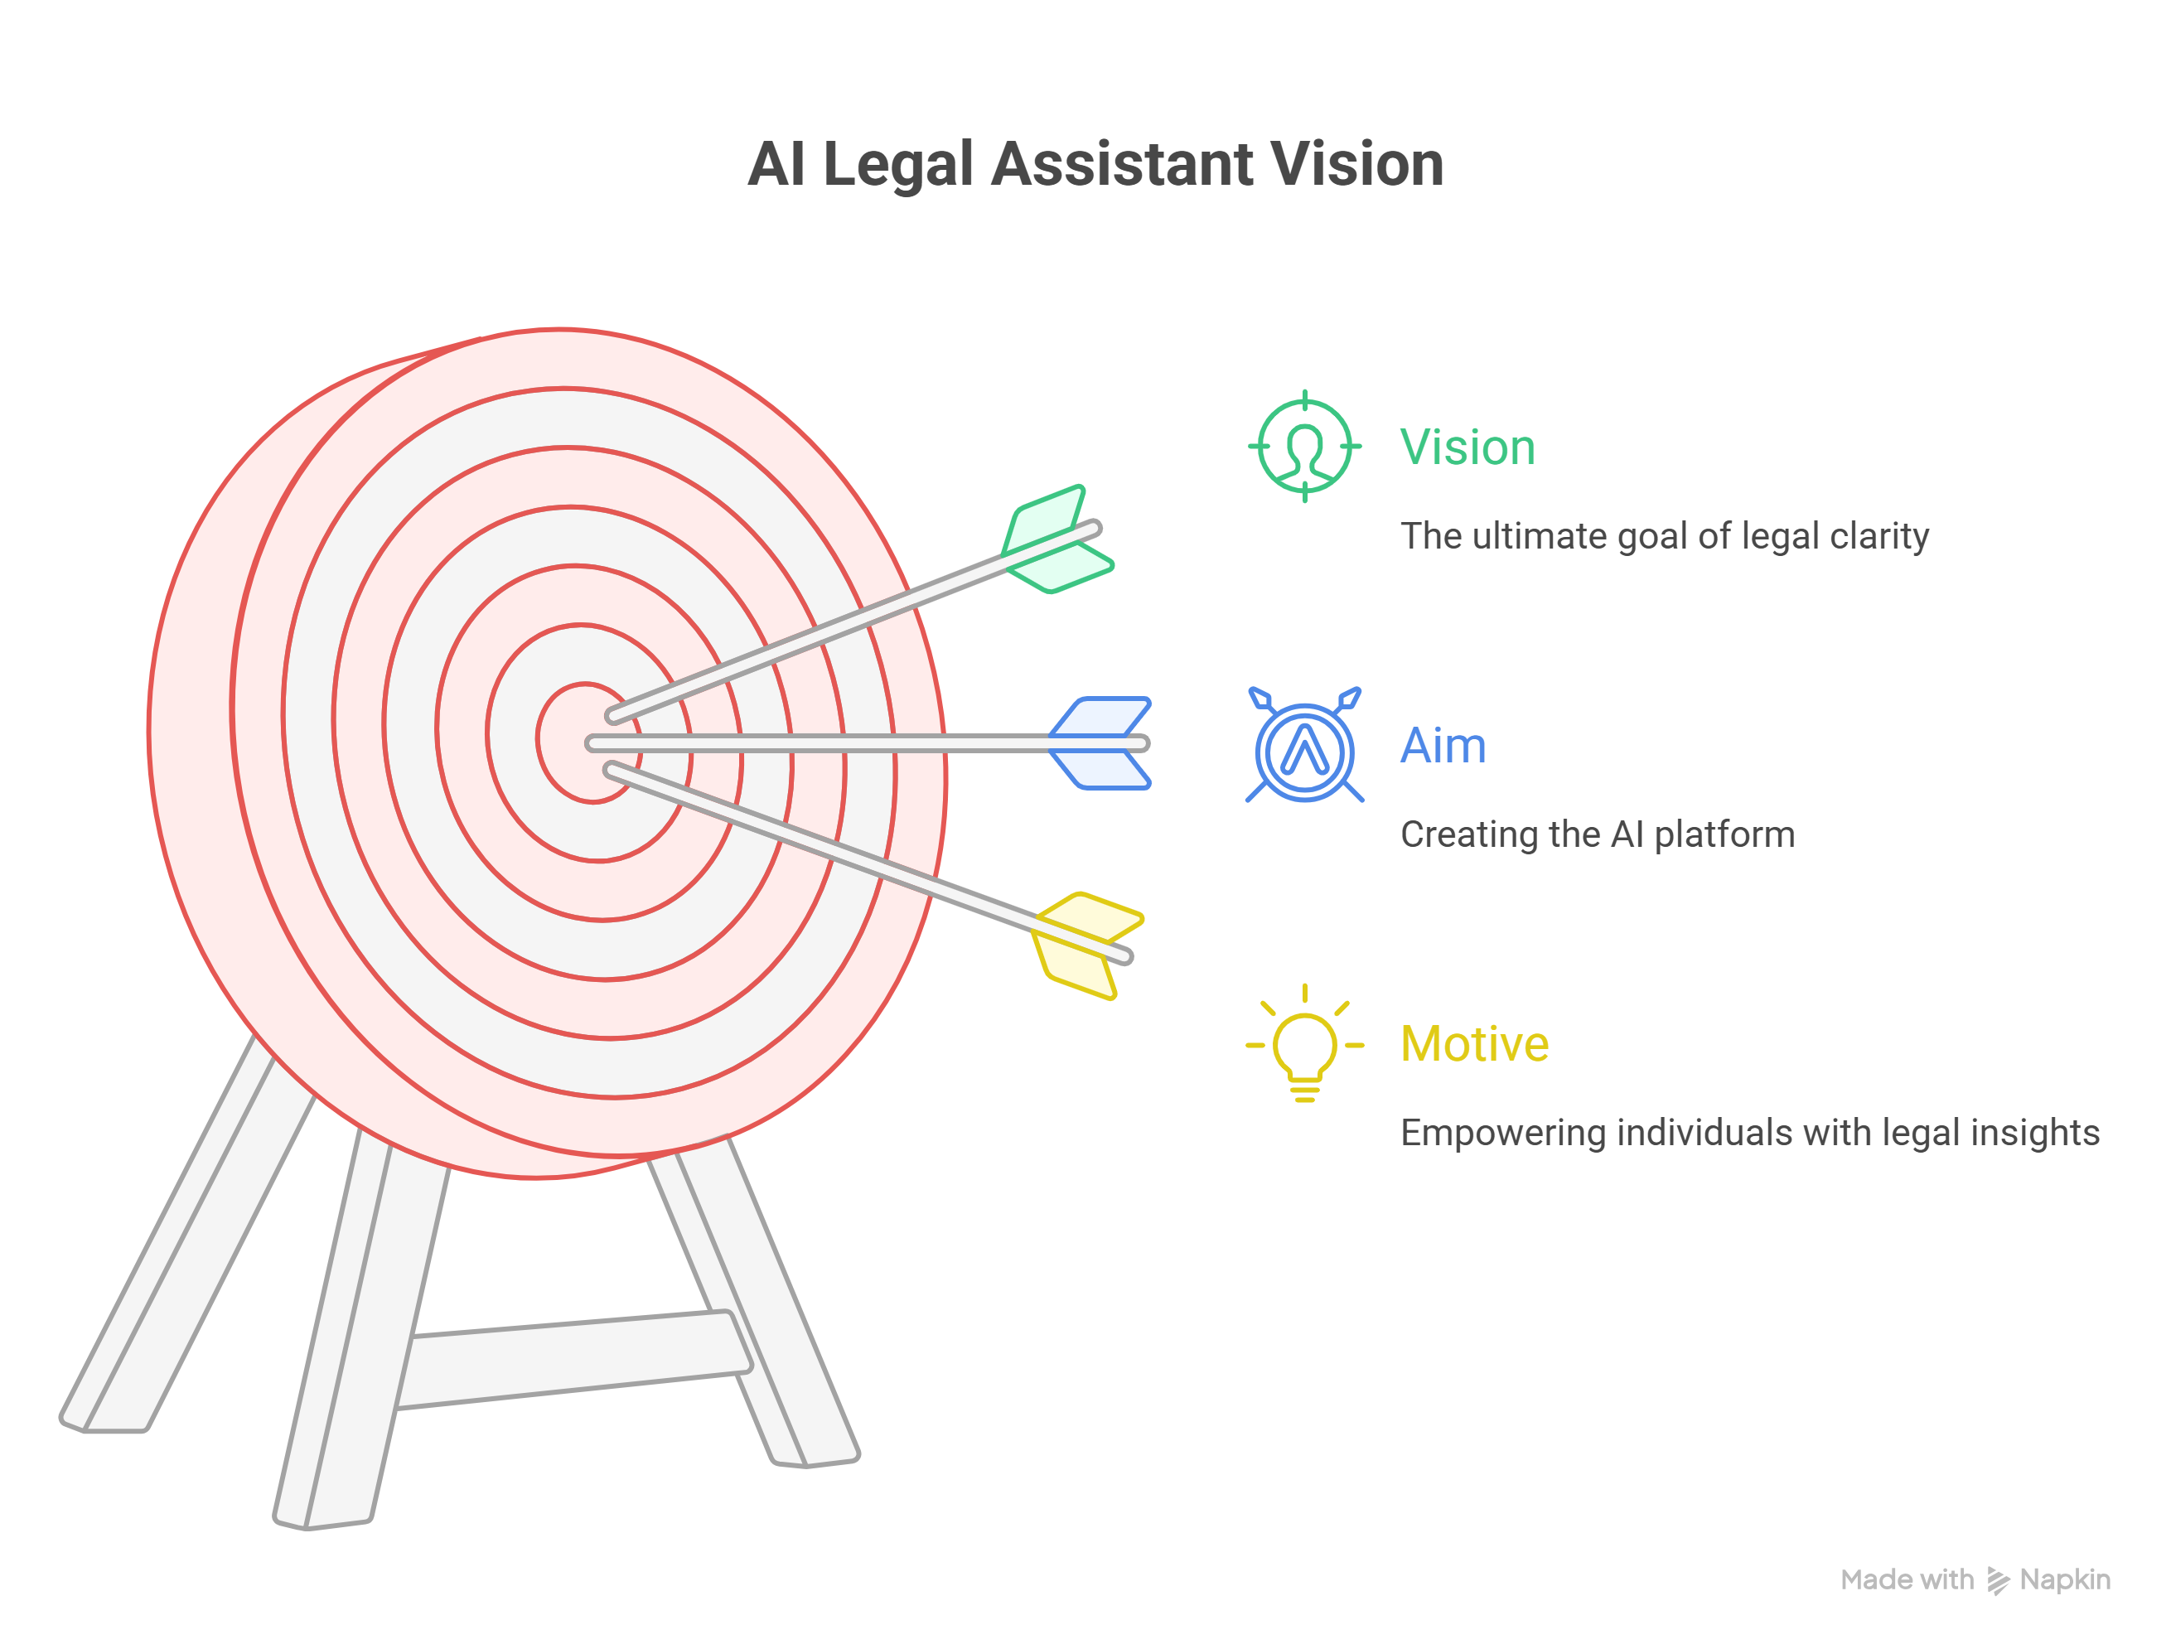

* **Motive:** To empower individuals without legal expertise to confidently understand and assess contracts using AI.
* **Aim:** To create a web-based AI-powered platform that identifies risky or non-standard clauses in legal documents and translates them into simple, understandable summaries.
* **Vision:** To become the go-to assistant for freelancers, students, and small businesses needing instant legal clarity.

## 4. Problem Statement –

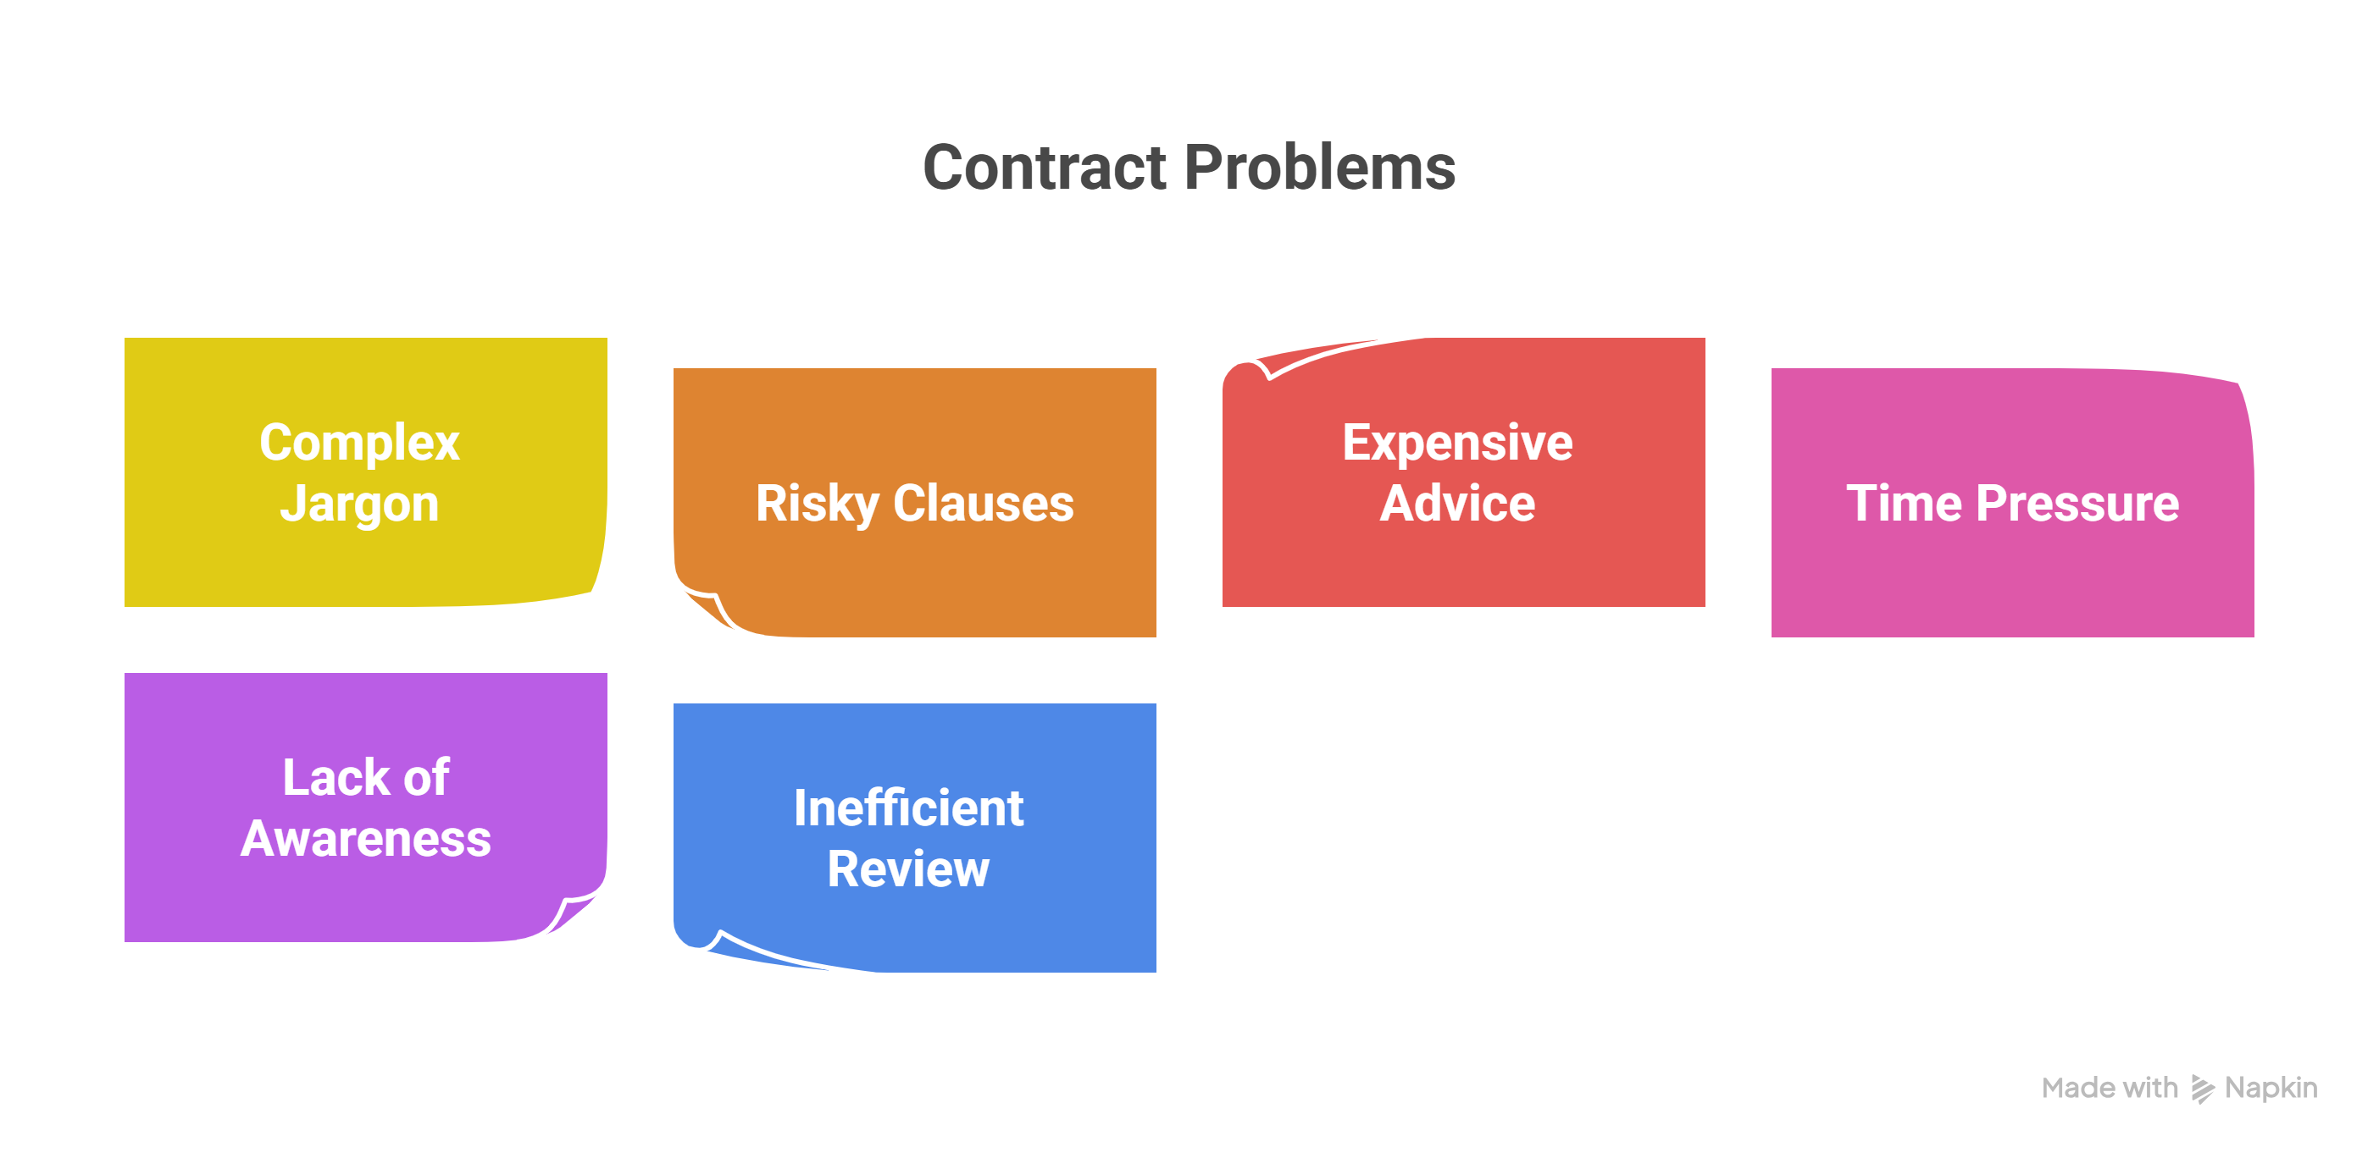

* + Legal jargon is complex for non-lawyers
  + Risky clauses often go unnoticed
  + Legal advice is expensive
  + People sign under time pressure
  + Lack of legal awareness
  + Manual clause review is inefficient

## 5. Core Concepts –

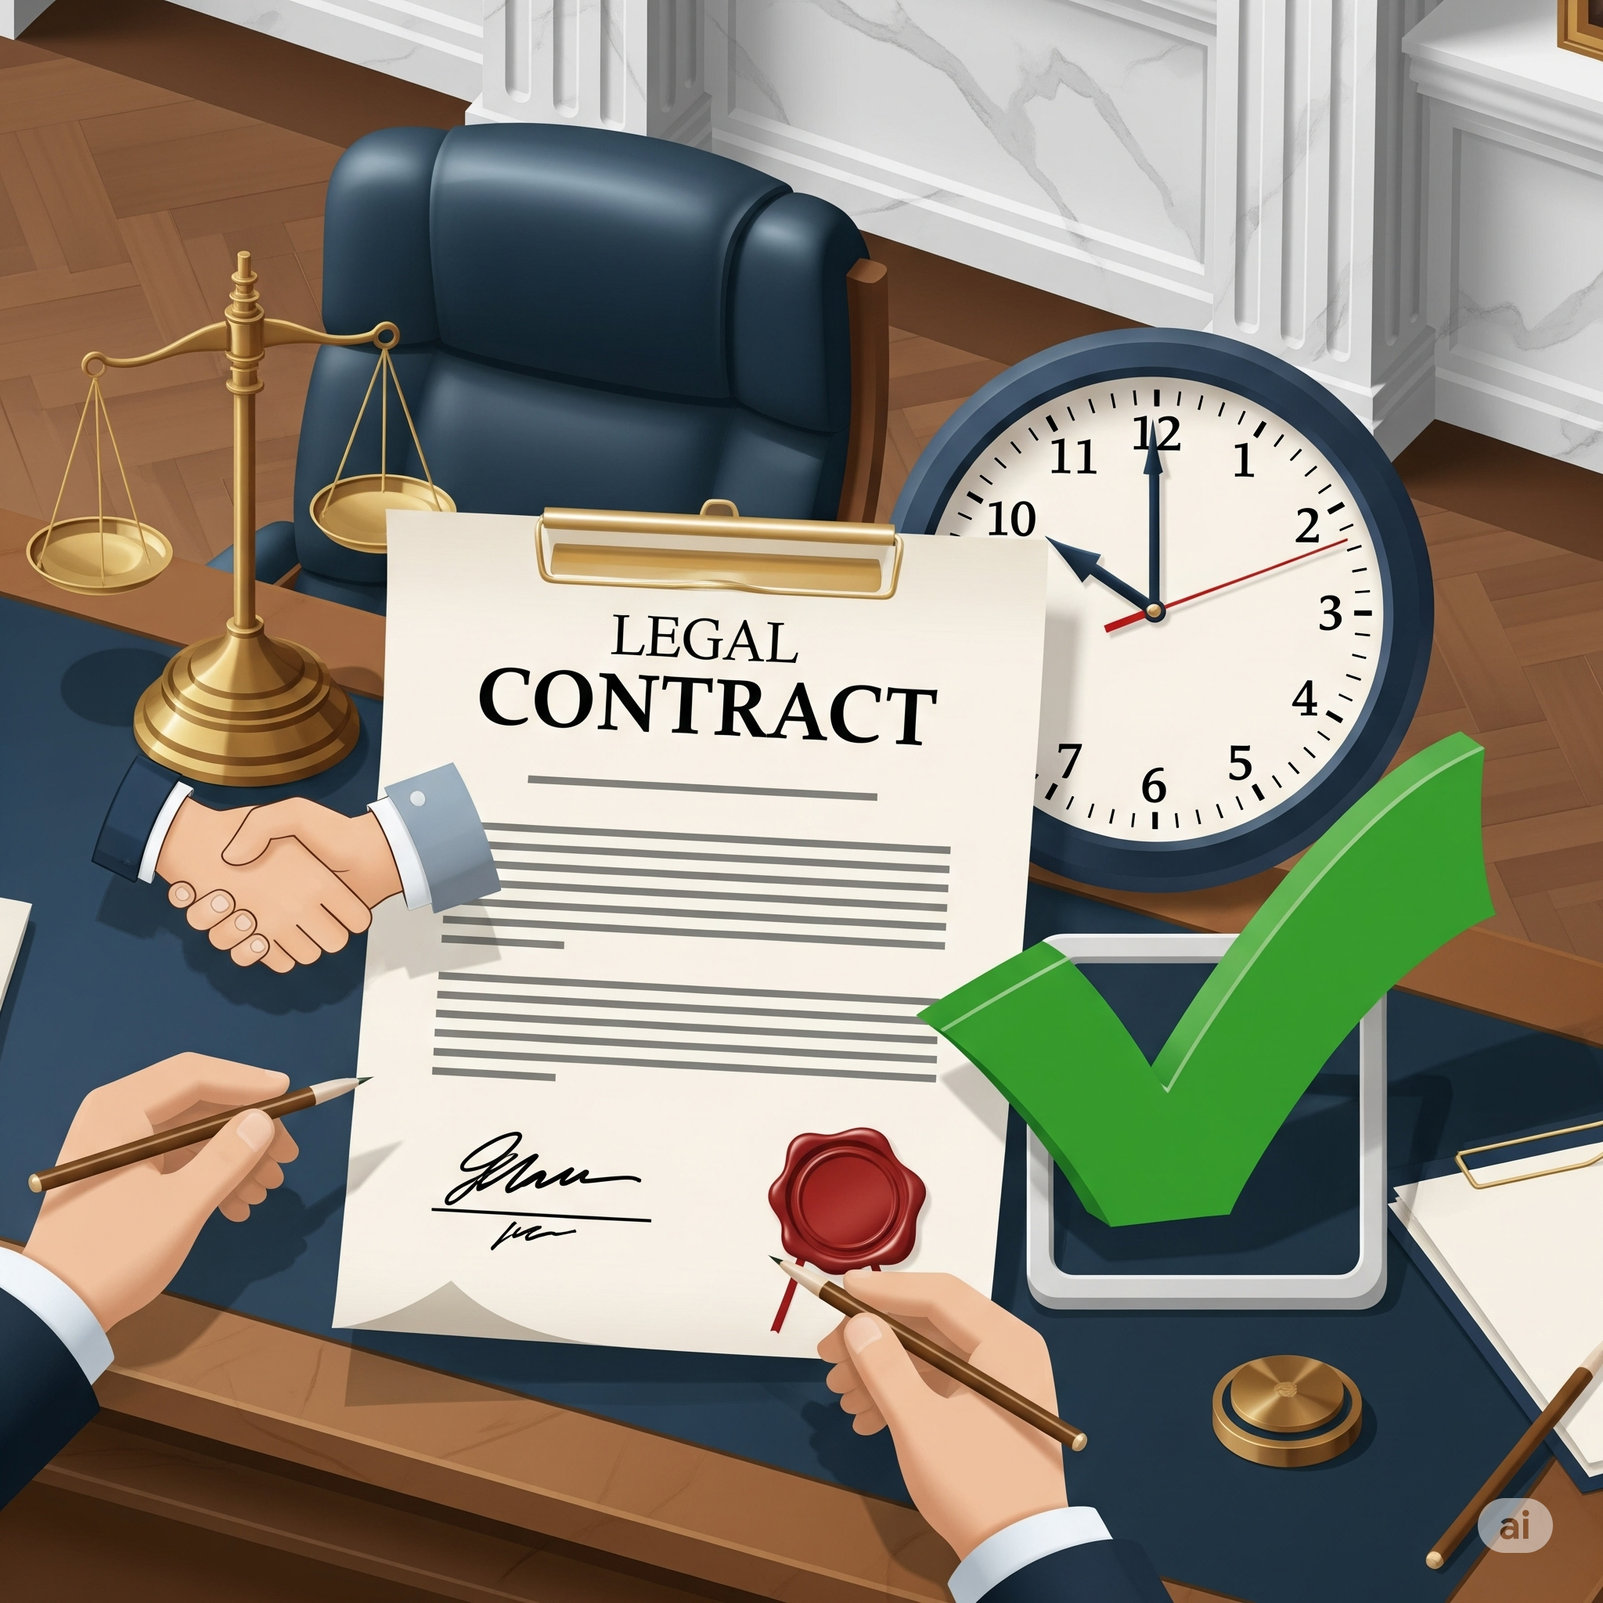

• **Contract:** A legal agreement between parties (e.g., paying Zomato for food delivery).

• **Compliance:** Following rules in a contract (e.g., no loud music after 10 PM in a rental agreement).

## 6. Proposed Solution –

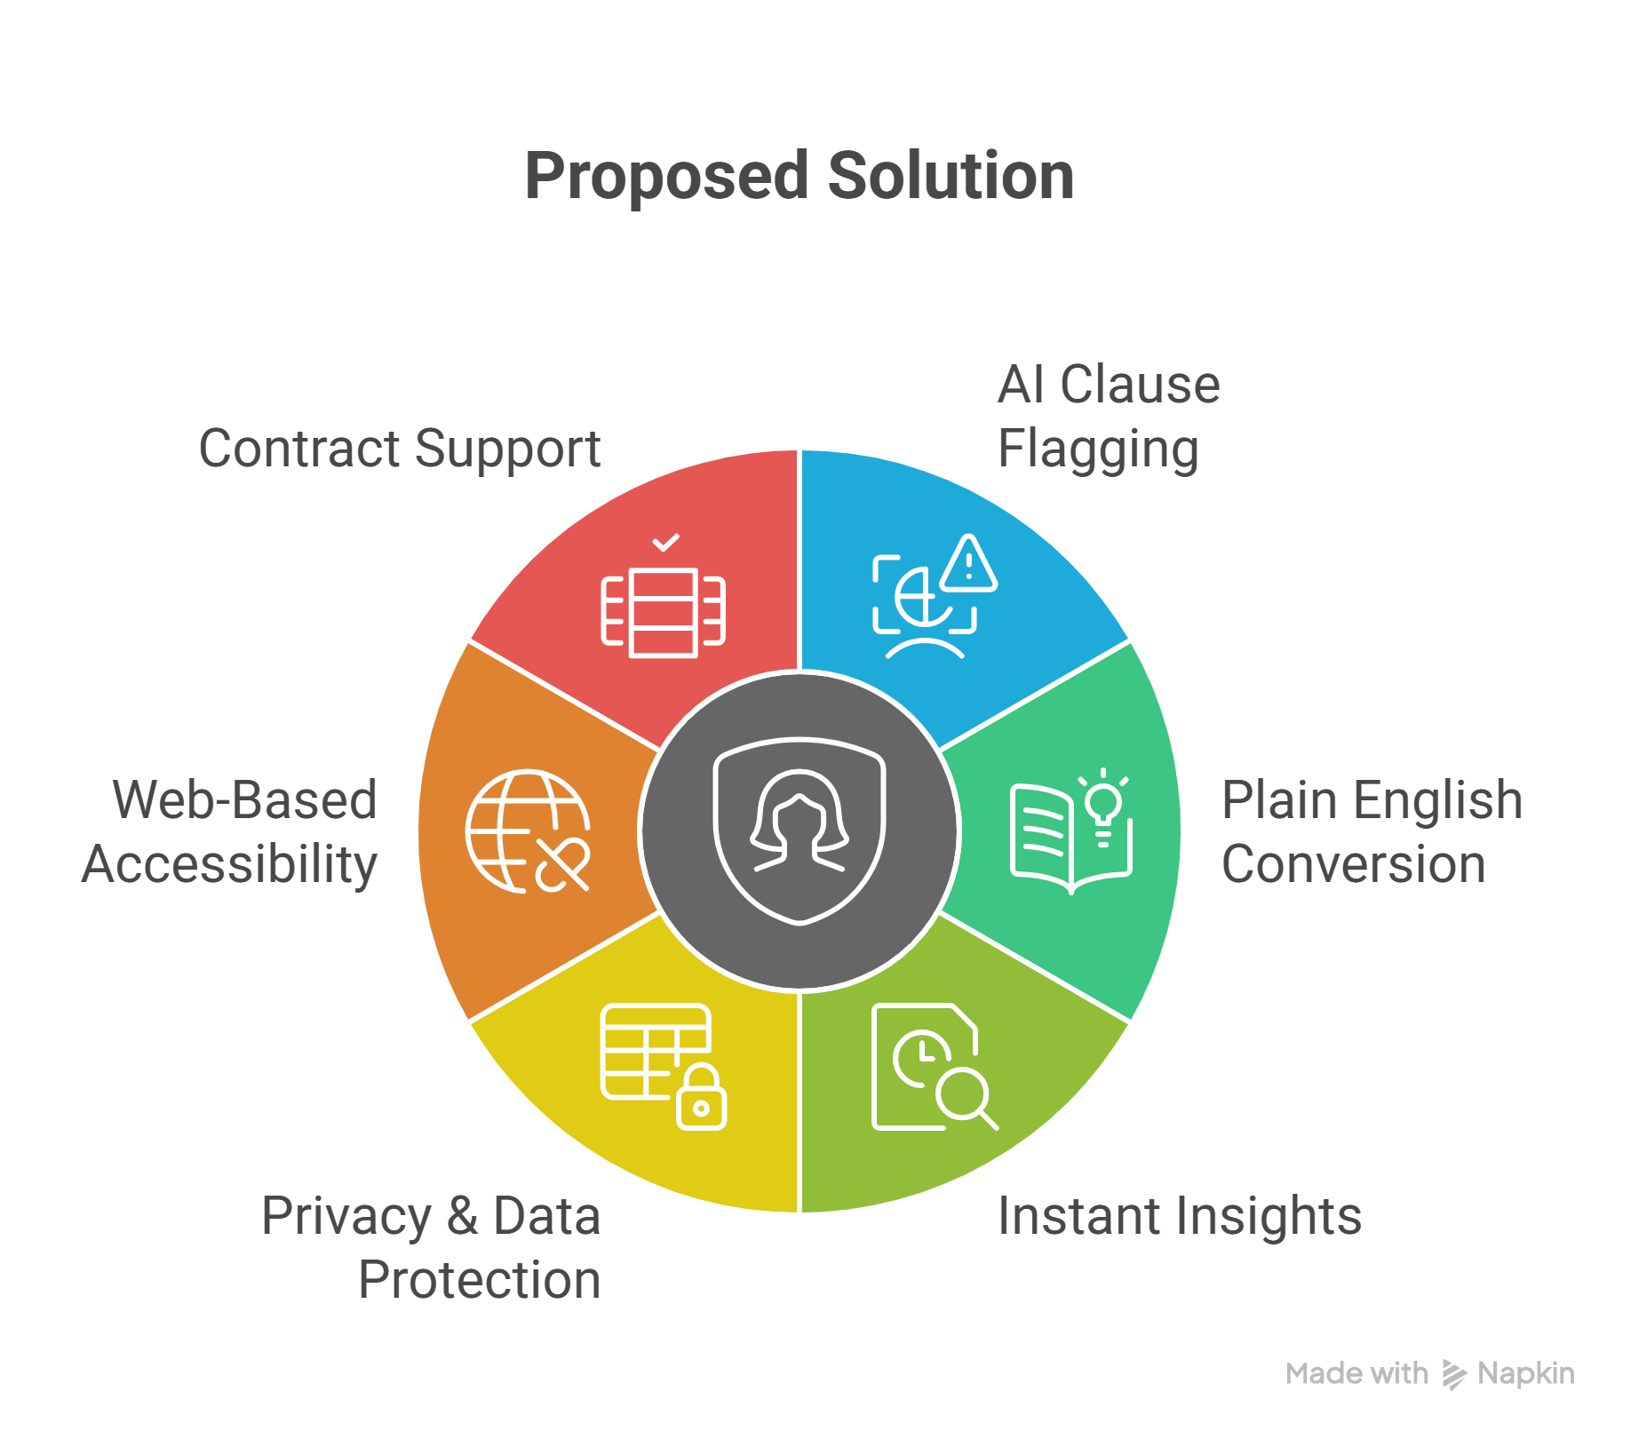

* + AI flags risky/non-standard clauses
  + Converts legal language into plain English
  + Provides instant insights
  + Ensures privacy & data protection
  + Web-based and easy to use
  + Supports NDAs, rental, freelance contracts, etc.

## 7. Real-Life Examples of Risky Clauses –

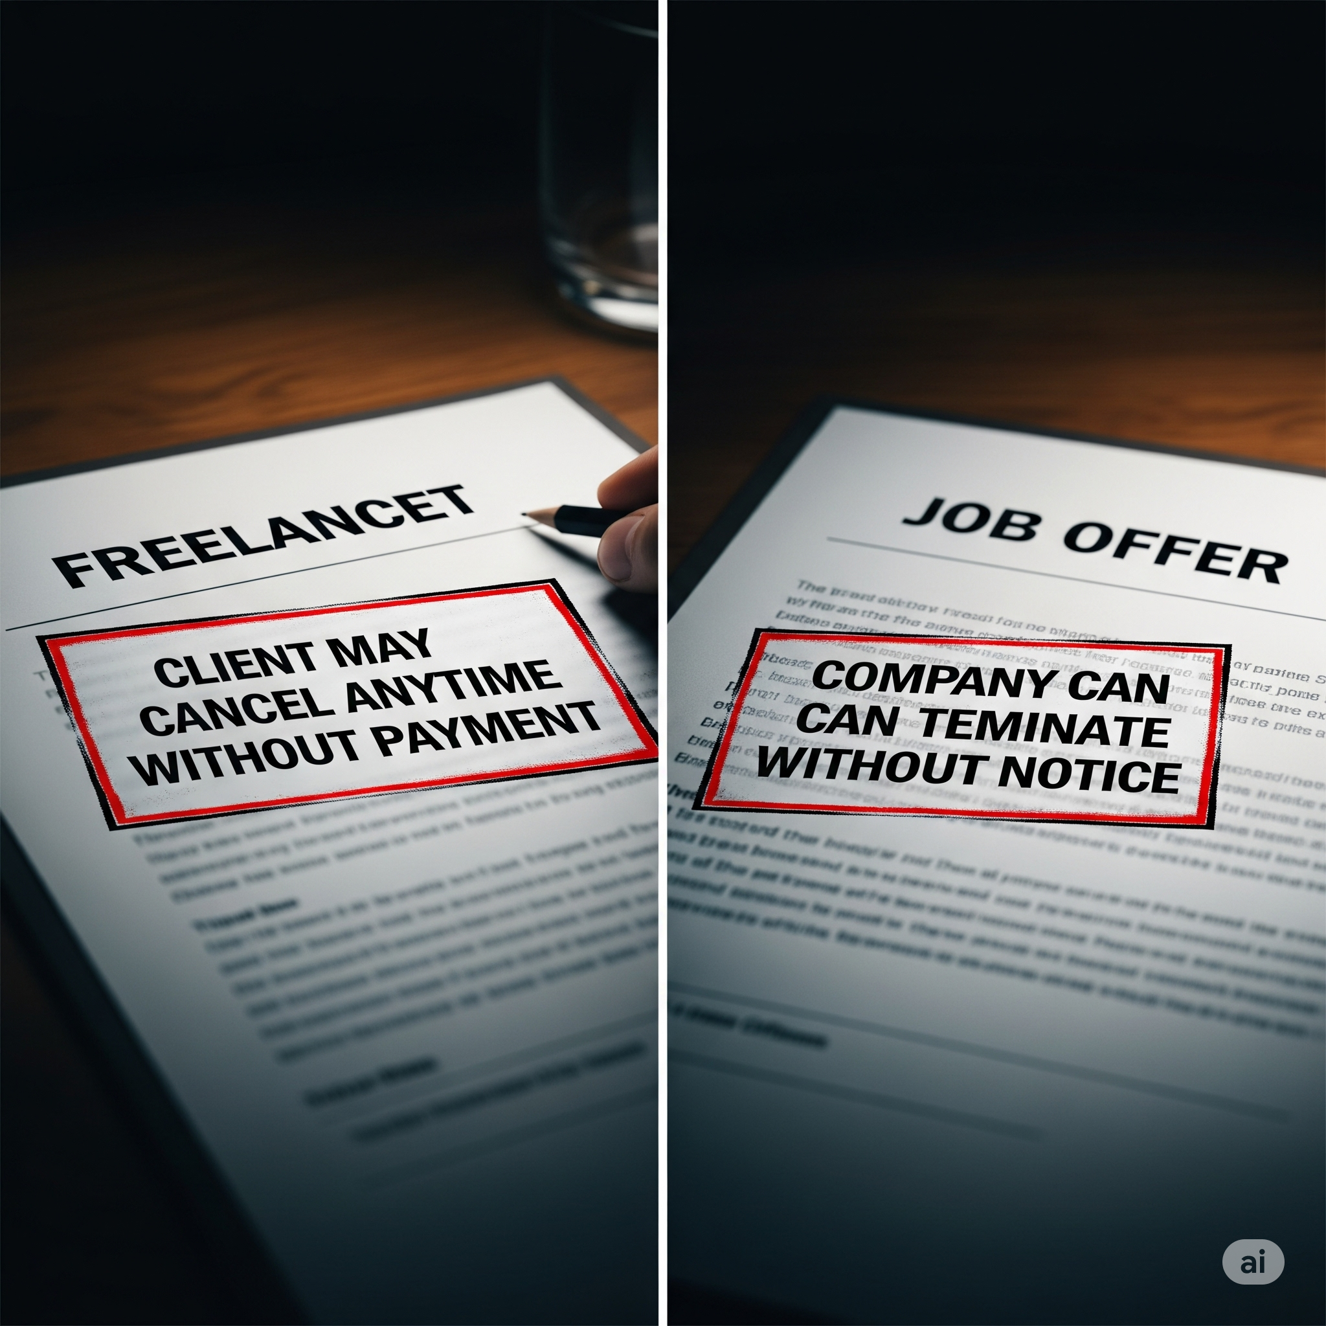

• **Freelancer Clause:** 'Client may cancel anytime without payment' → **Risk:** No income security.

• **Job Offer Clause:** 'Company can terminate without notice' → **Risk:** No job security.

## 8. User Demographics and Psychology –

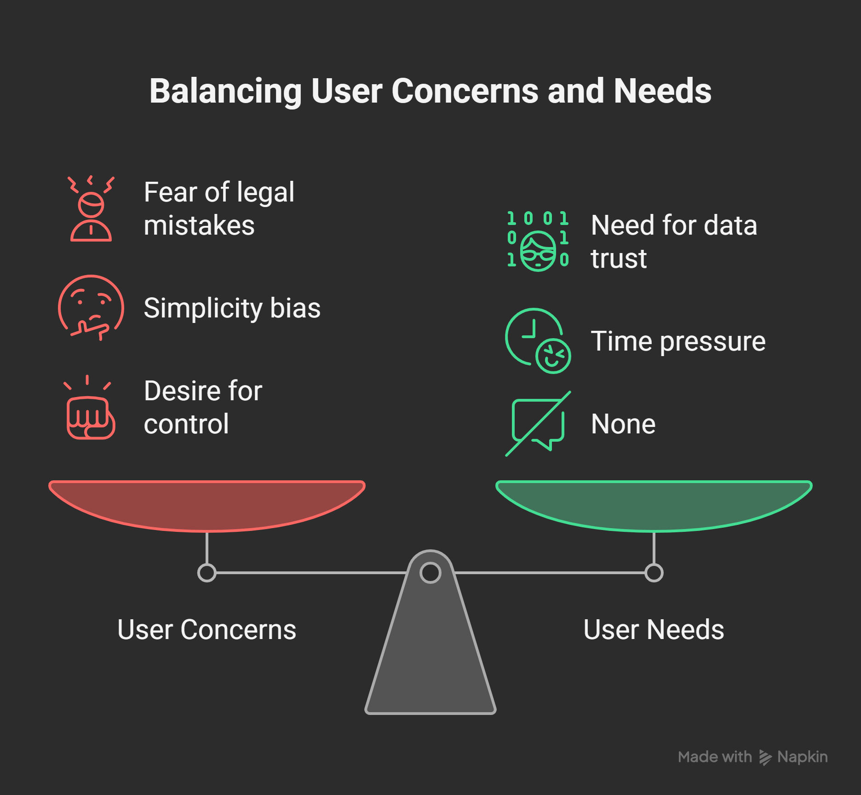

* **Target Age:** 20–50 (freelancers, students, small business owners).
* Fear of legal mistakes
* Need for data trust
* Simplicity bias
* Time pressure
* Desire for control

## 9. Innovation –

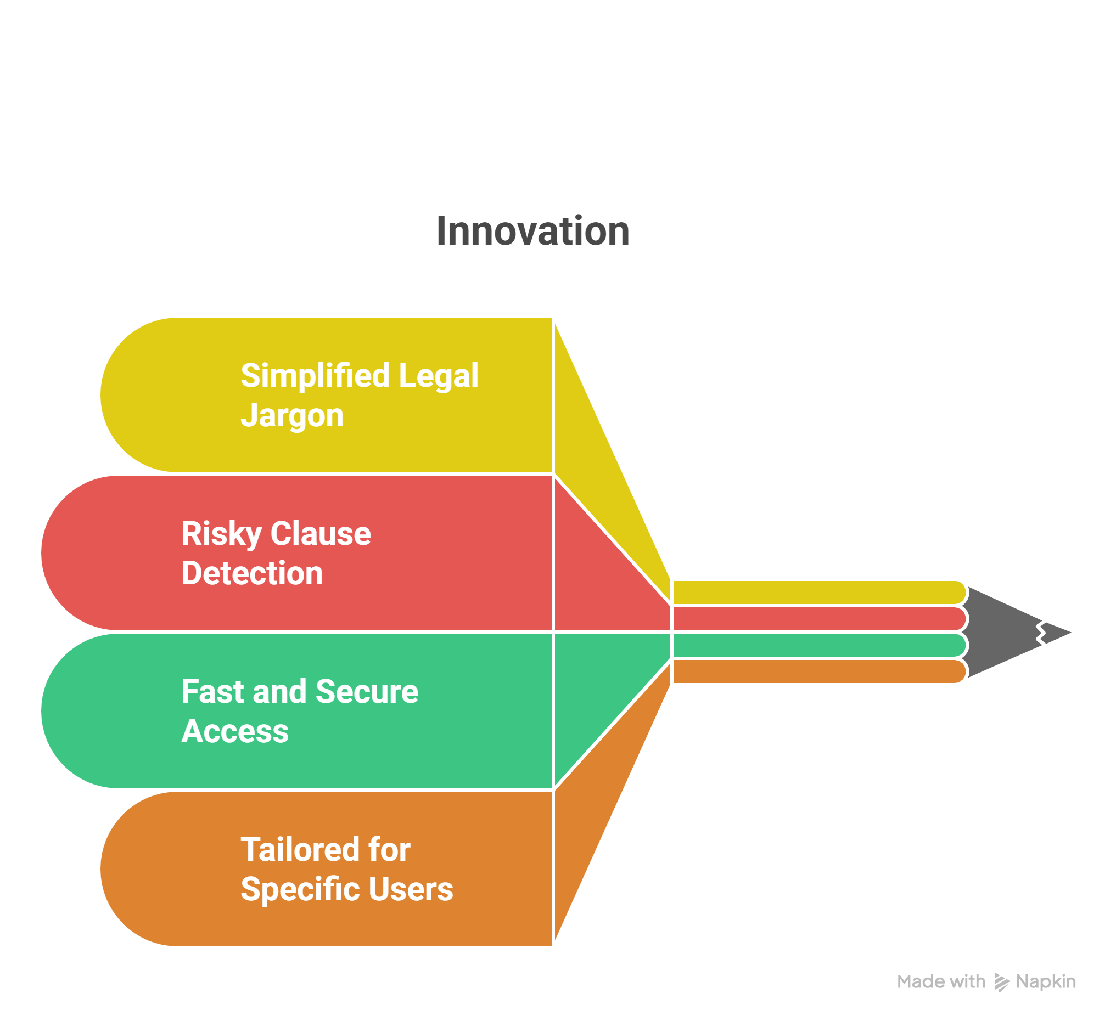

* AI for non-lawyers
* Simplifies legal jargon
* Flags risky clauses
* Fast, secure & accessible
* Built for freelancers, students, SMBs

## 10. Categories Of AI Legal Assistance –

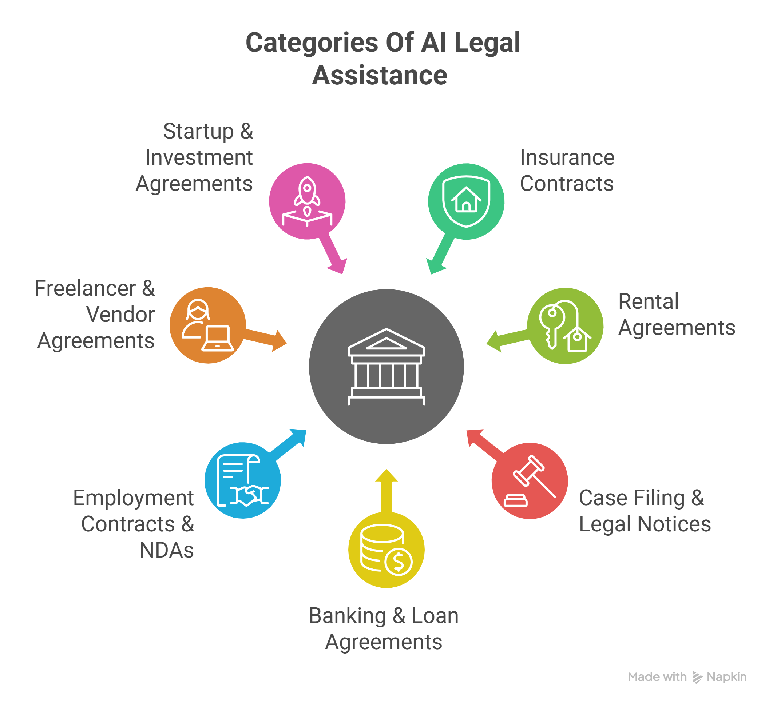

**1. Insurance Contracts -**

* Highlights exclusions, deadlines, and claim conditions in simple terms.

**2. Rental Agreements**

* Detects risky clauses like sudden eviction or unfair rent hikes.

**3. Case Filing & Legal Notices**

* Converts legal notices into clear, actionable instructions.

**4. Banking & Loan Agreements**

* Flags hidden penalties, repayment traps, and variable interest terms.

**5. Employment Contracts & NDAs**

* Simplifies job offers, termination clauses, and confidentiality terms.

**6. Freelancer & Vendor Agreements**

* Identifies vague scope, no-payment risks, and cancellation clauses.

**7. Startup & Investment Agreements**

* Warns about equity dilution, founder rights, and decision control.

## 11. Impact –

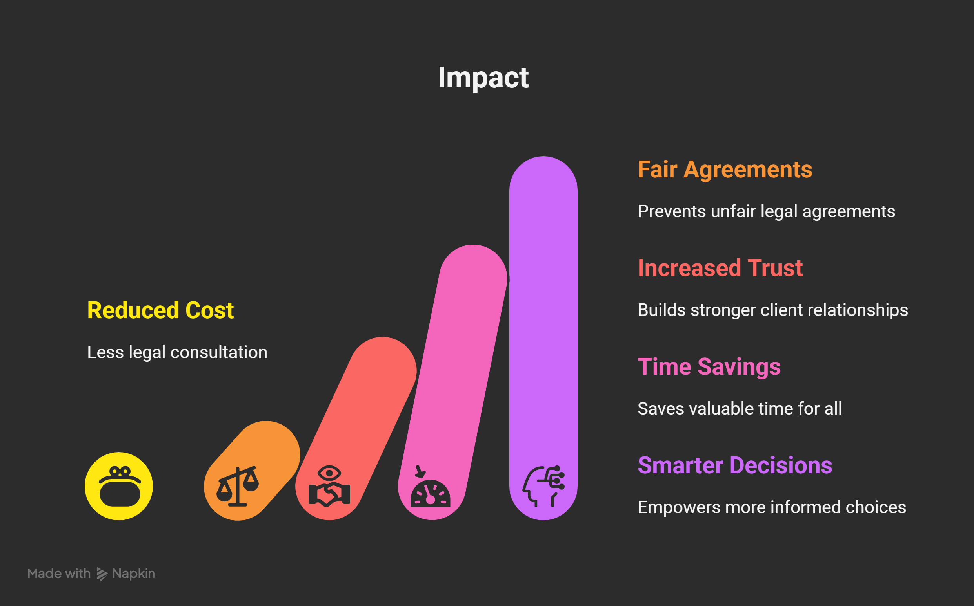

* Reduces legal consultation cost
* Prevents unfair agreements
* Builds trust
* Saves time
* Empowers smarter decisions

## 12. Technology Stack –

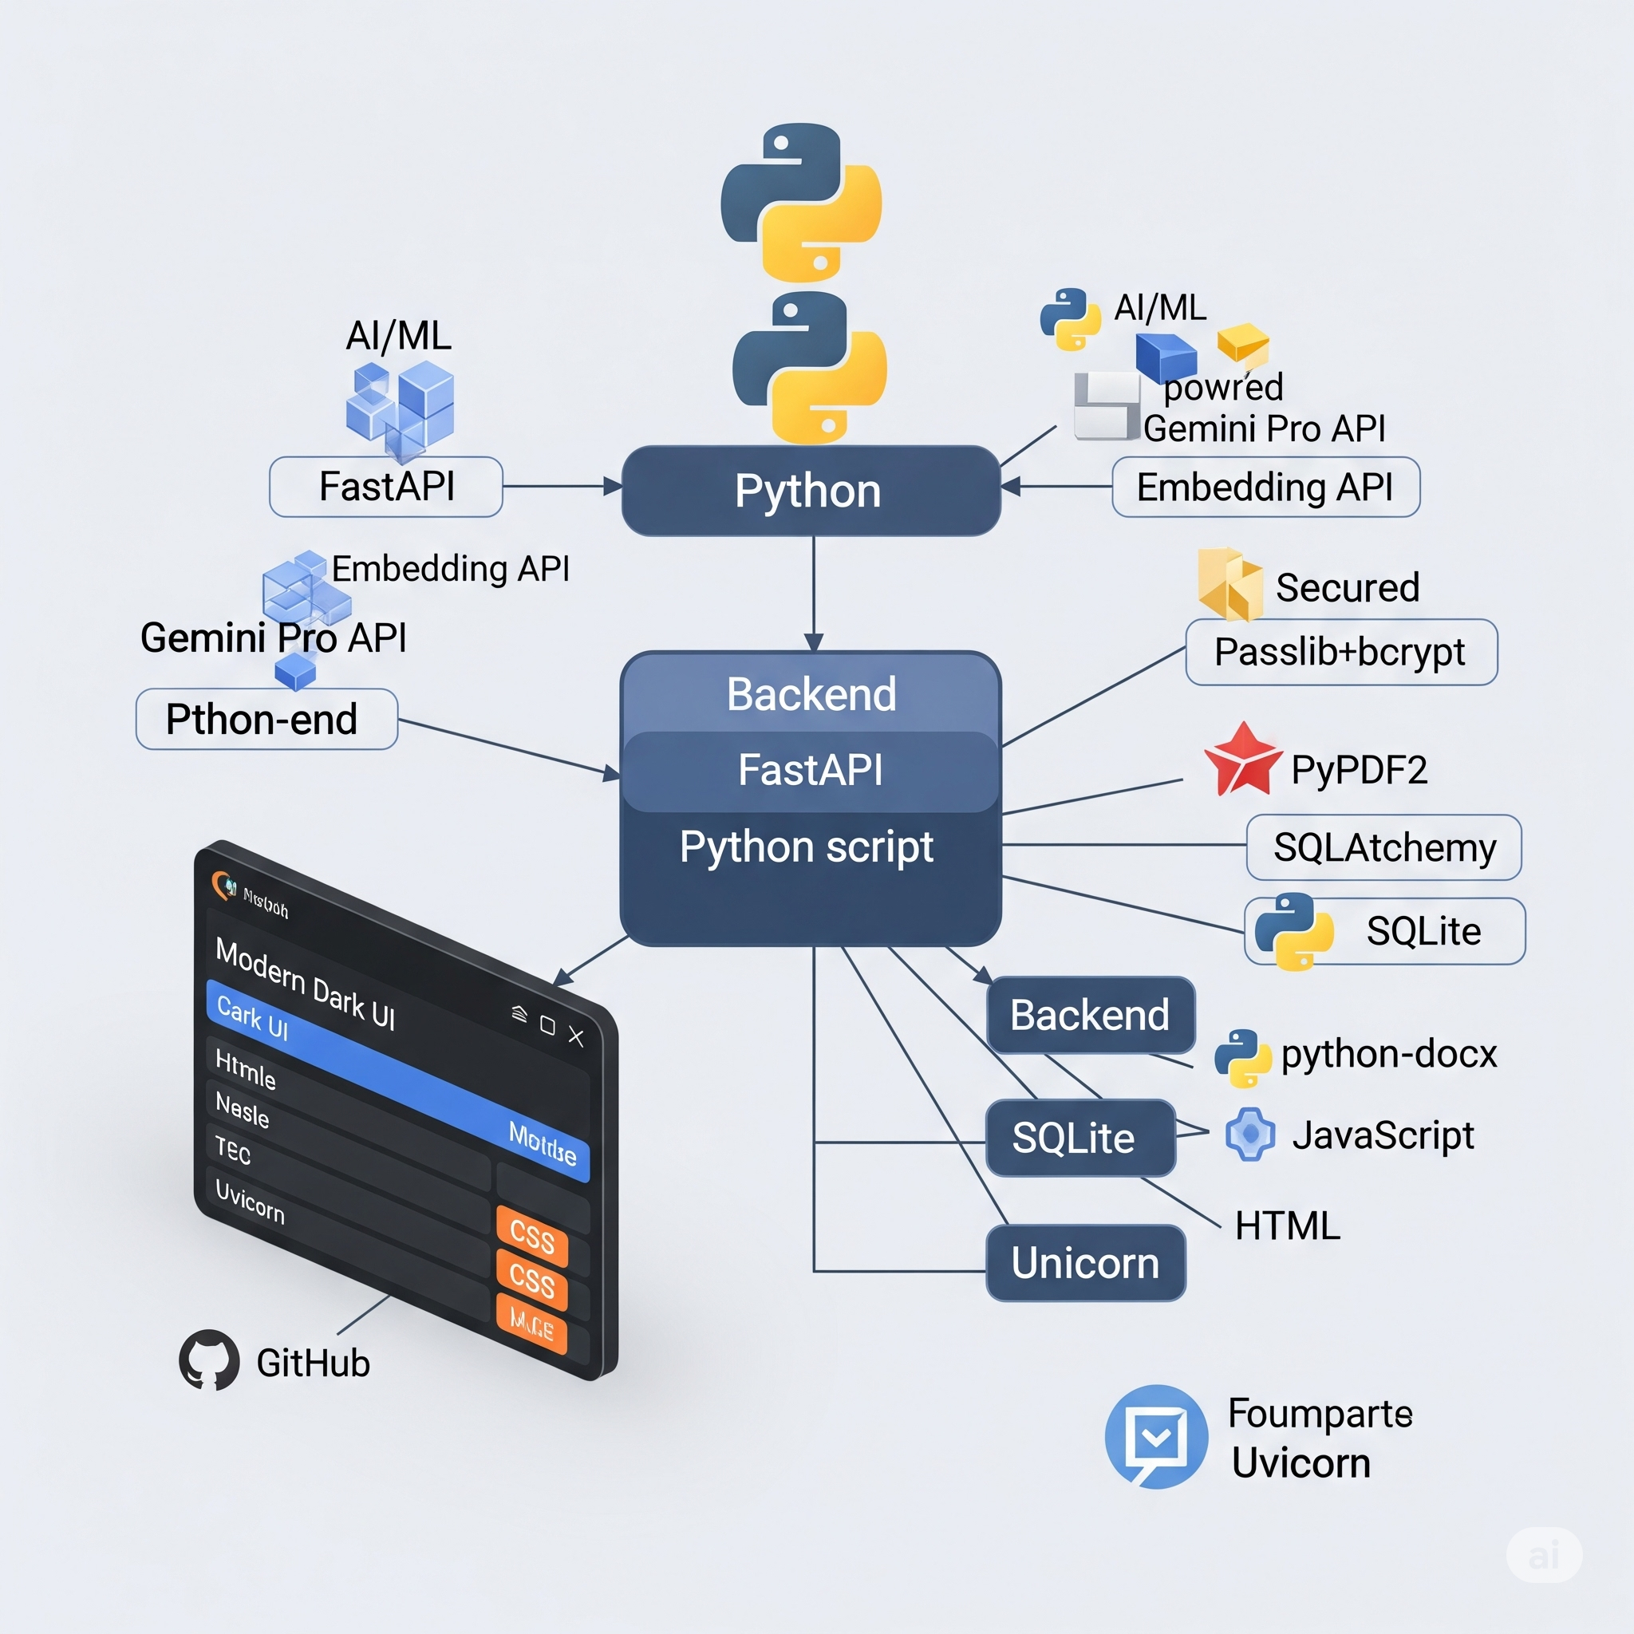

* **AI/ML:** Python, Gemini Pro API, Embedding API, Passlib+bcrypt
* **Backend:** FastAPI, SQLAlchemy, SQLLite, PyPDF2/python-docx
* **Frontend:** HTML, CSS, JavaScript (Dark UI)
* **Tools:** GitHub, Uvicorn

## 13. Technical Architecture –

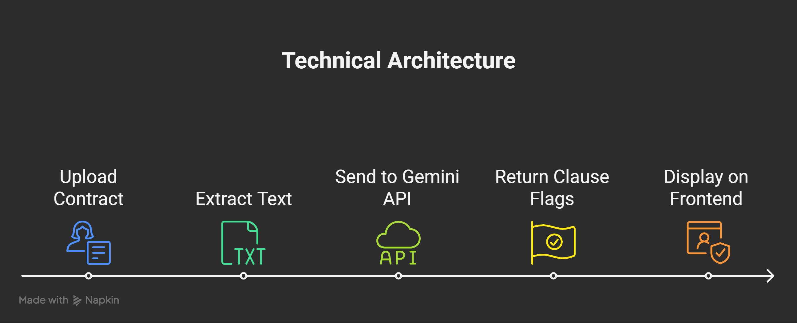

1. Upload contract (PDF/DOCX)  
   2. Extract text using PyPDF2 or python-docx  
   3. Send to Gemini API for analysis  
   4. Return clause flags & plain summaries  
   5. Display on frontend interface securely

## 14. Competitor Analysis –

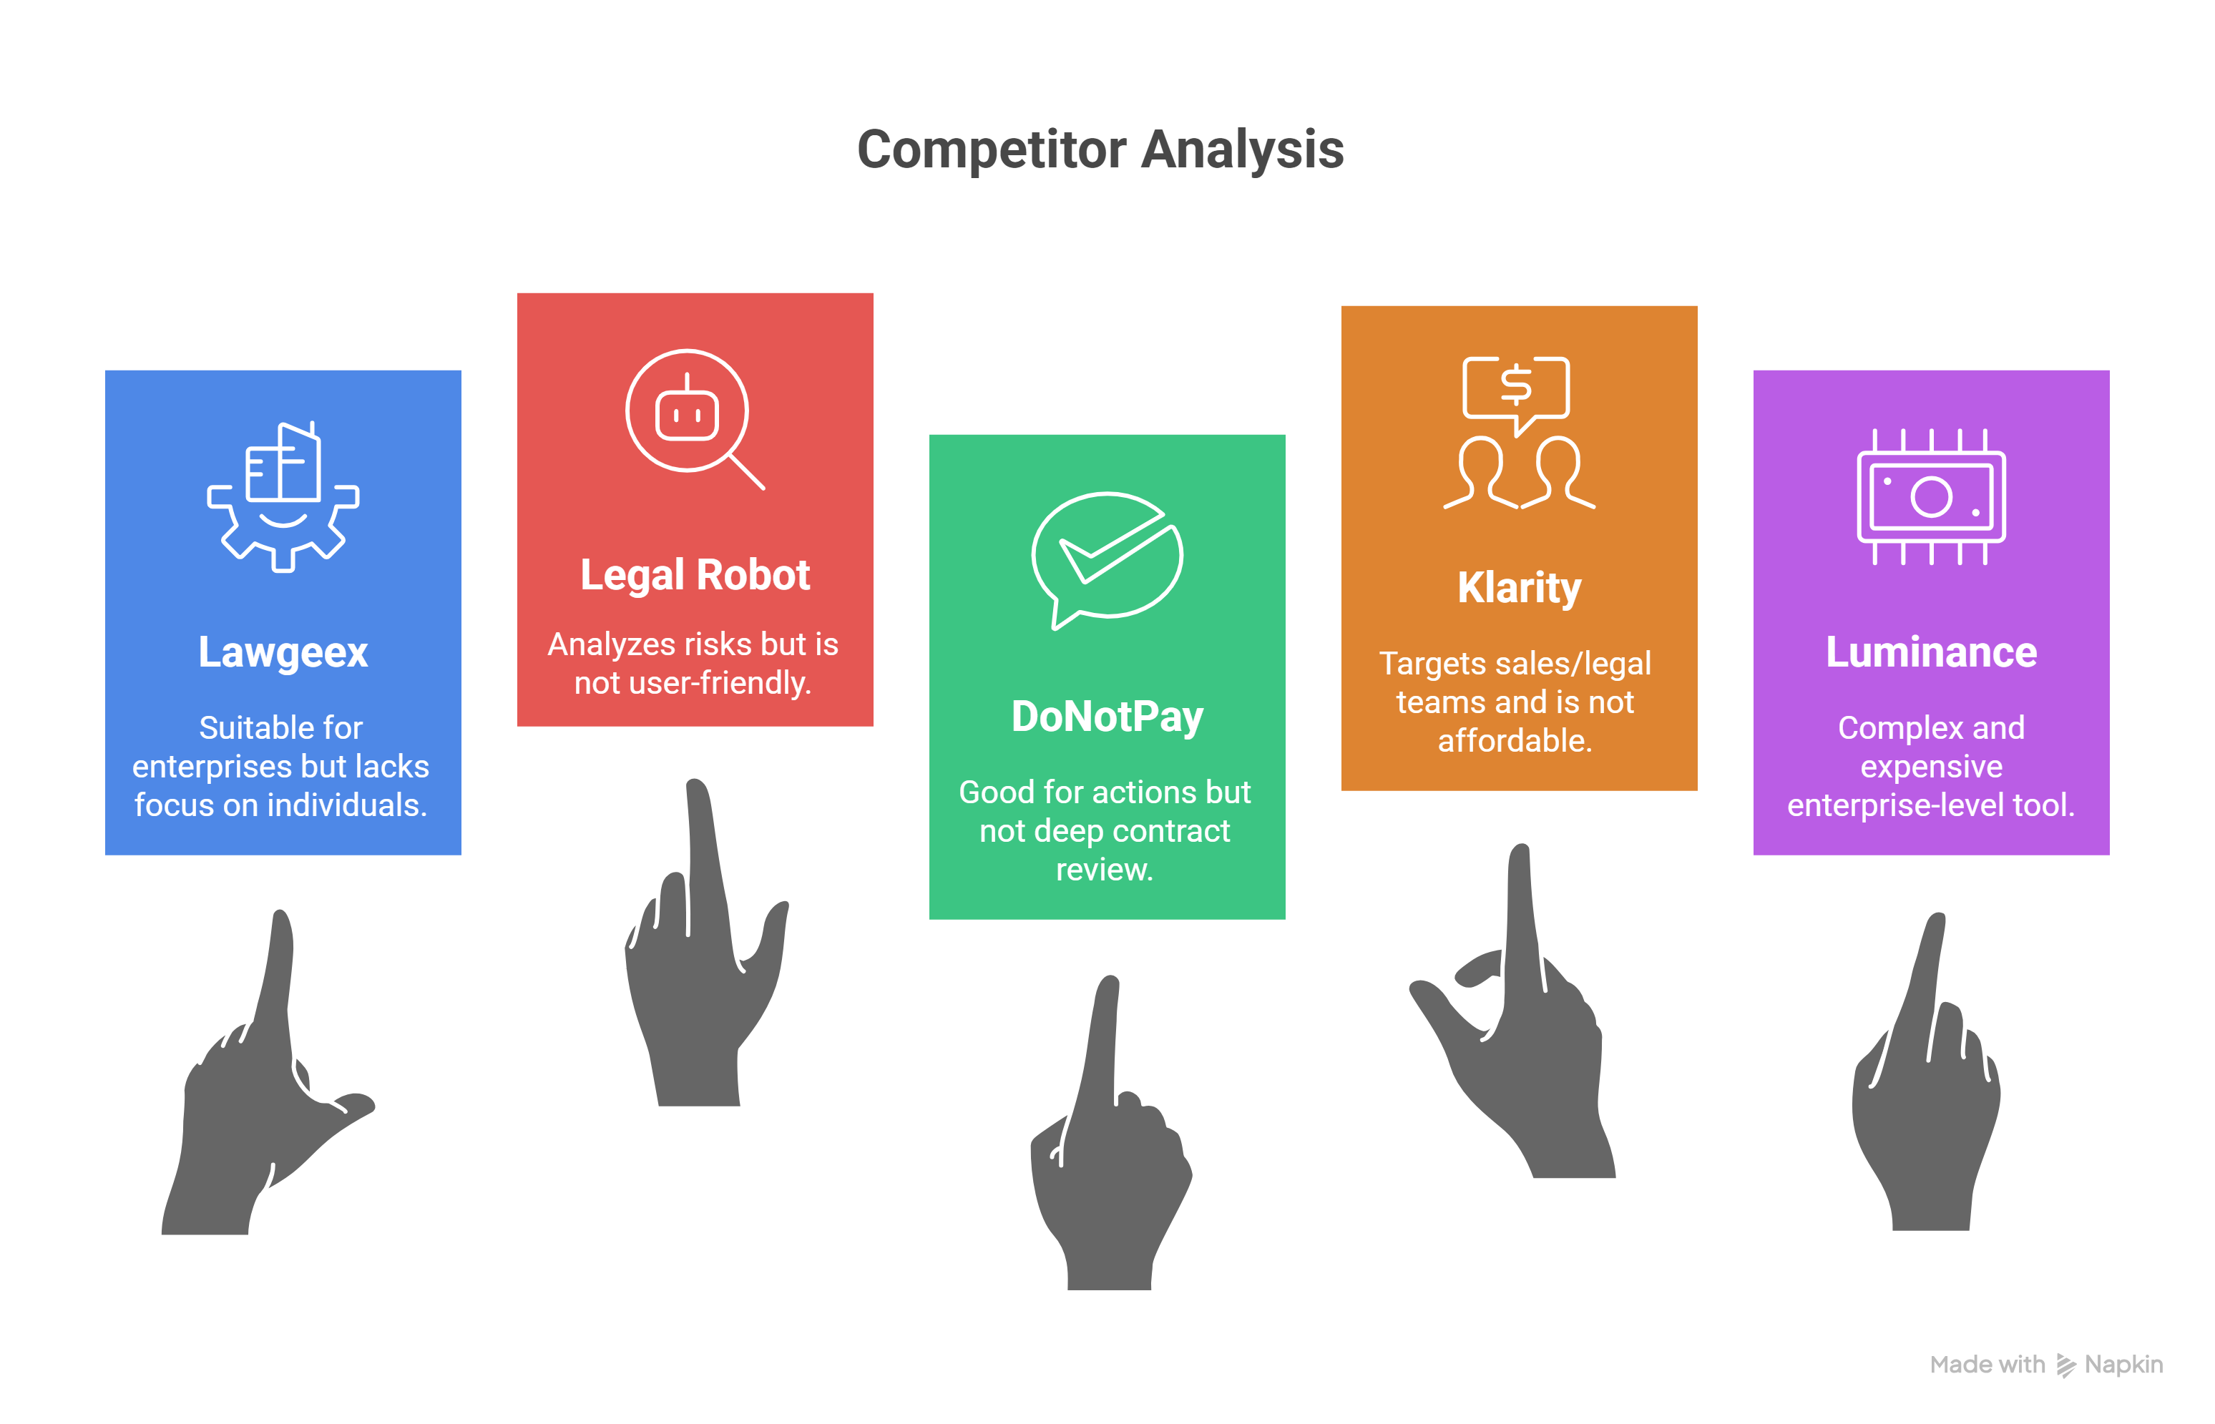

**Existing platforms in the legal AI space include:**

* **Lawgeex –** AI contract review for enterprises; lacks focus on individuals.
* **Legal Robot –** Analyzes legal risks but limited user-friendliness.
* **DoNotPay –** AI legal chatbot; good for actions, not deep contract review.
* **Klarity –** Targets sales/legal teams; not affordable for individuals.
* **Luminance –** Enterprise-level tool; complex and expensive.

Unlike these tools, our solution focuses on simplifying contract understanding specifically for individuals like freelancers and students.

## 14. Challenges Faced –

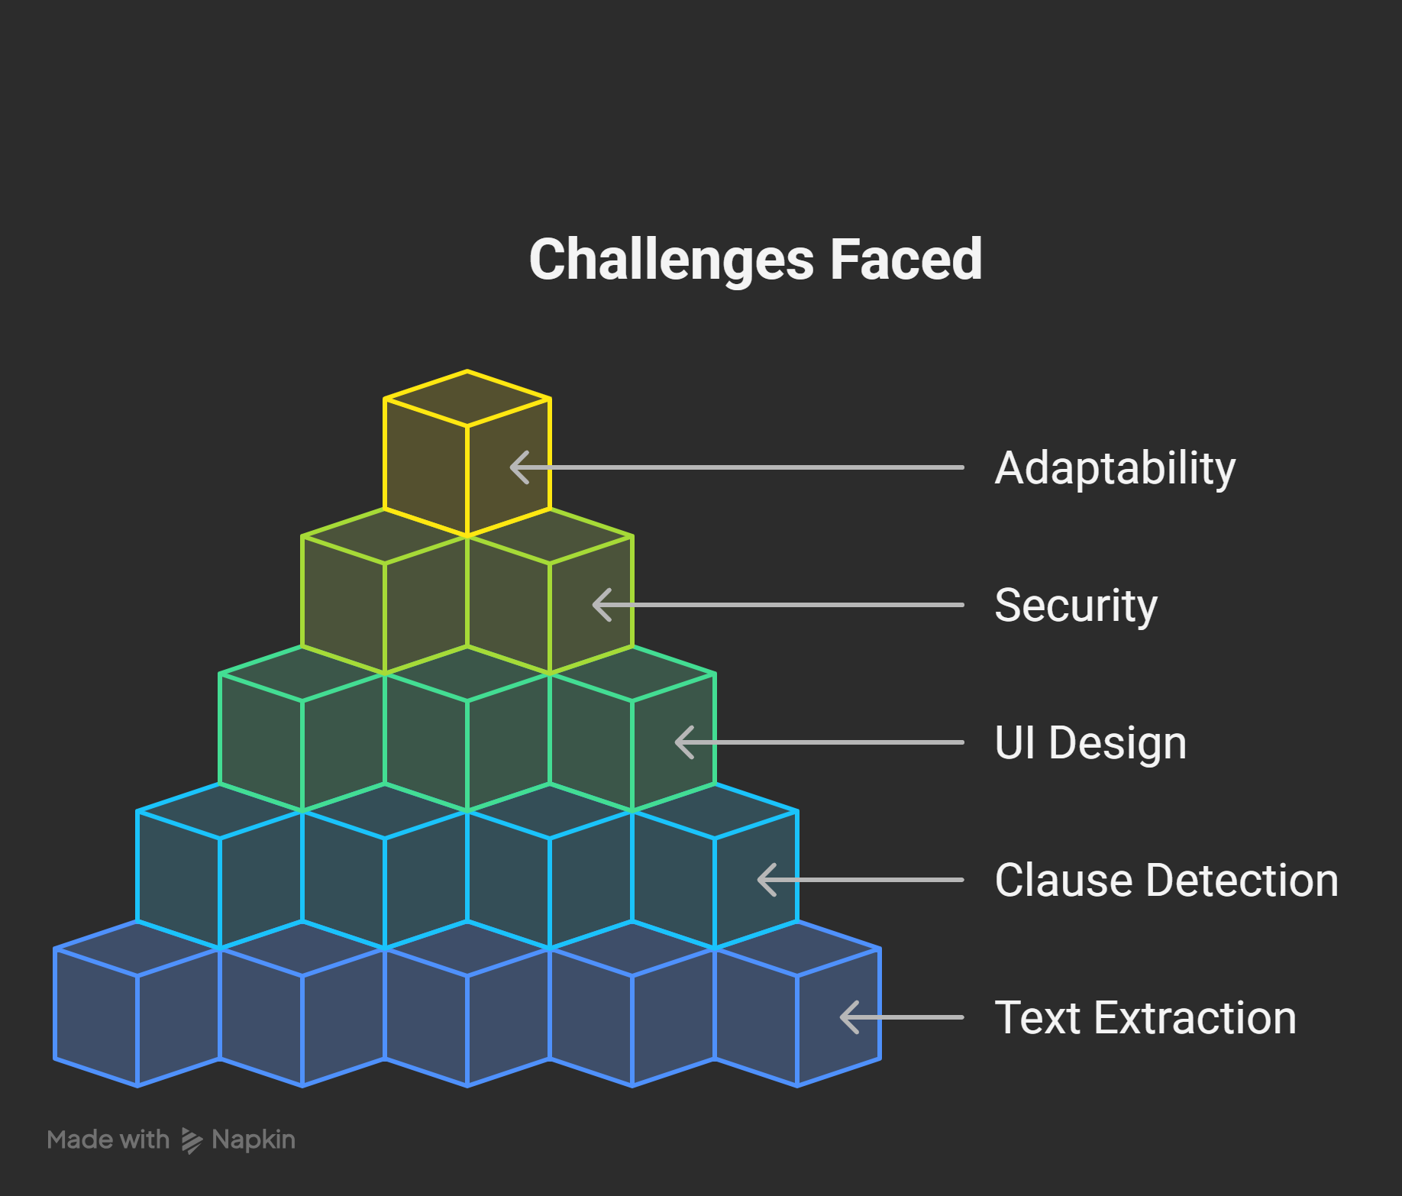

* Extracting accurate text from various formats
* Ensuring clause detection precision
* Designing a simple, trustworthy UI
* Securing user files and privacy
* Adapting across different contract types

## 15. Scalability –

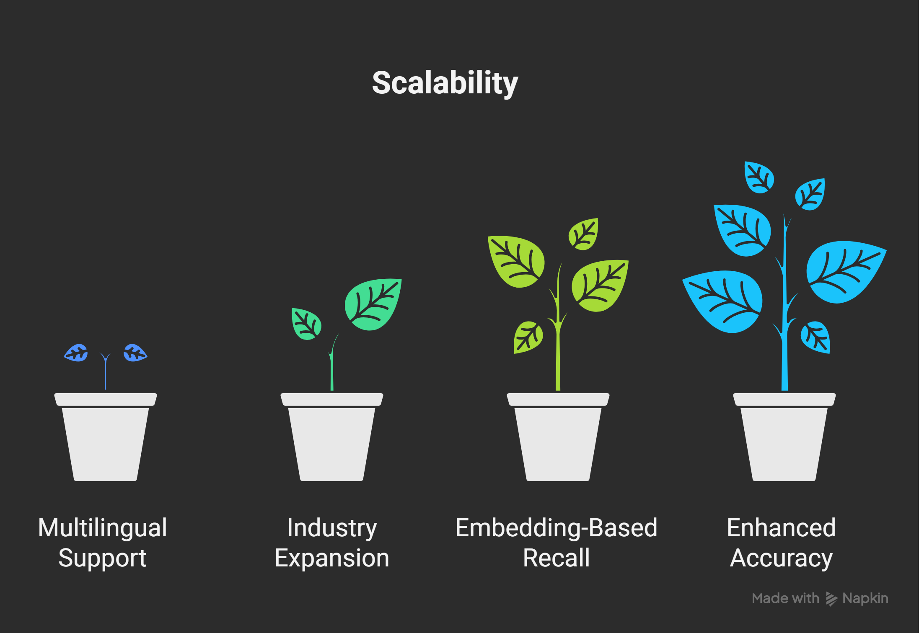

* The system can scale to other languages and industries (e.g., healthcare, insurance). Multilingual support and embedding-based document recall can enhance future accuracy and coverage.

**16. Our Prototype –**

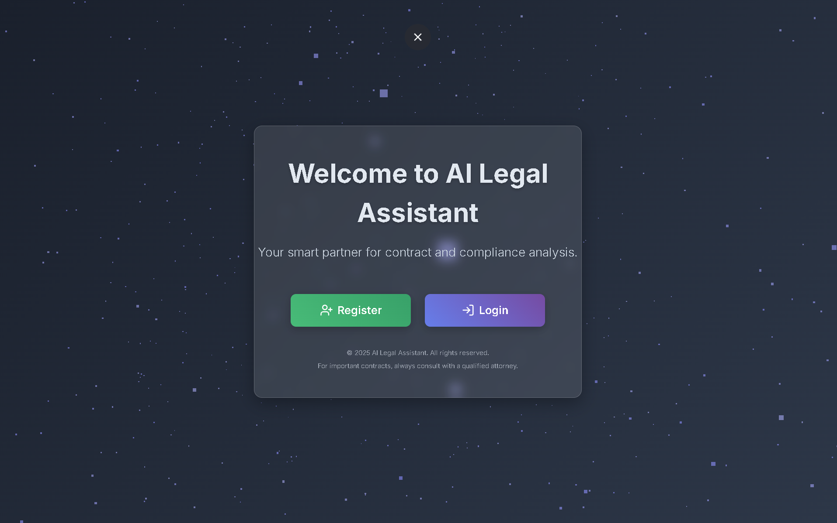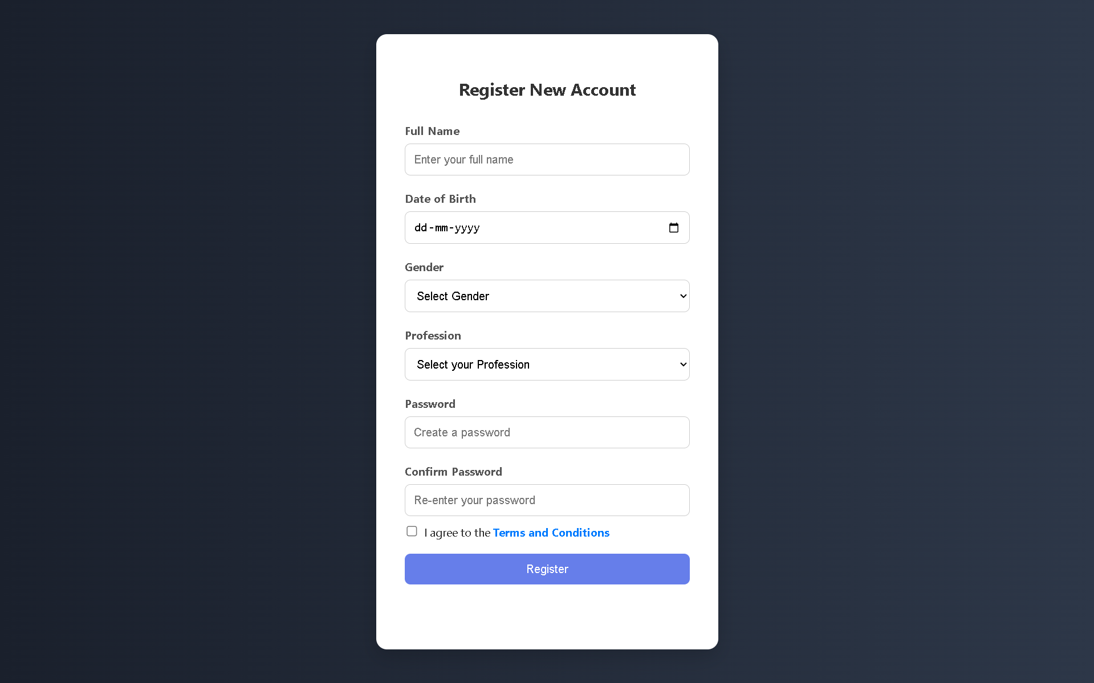

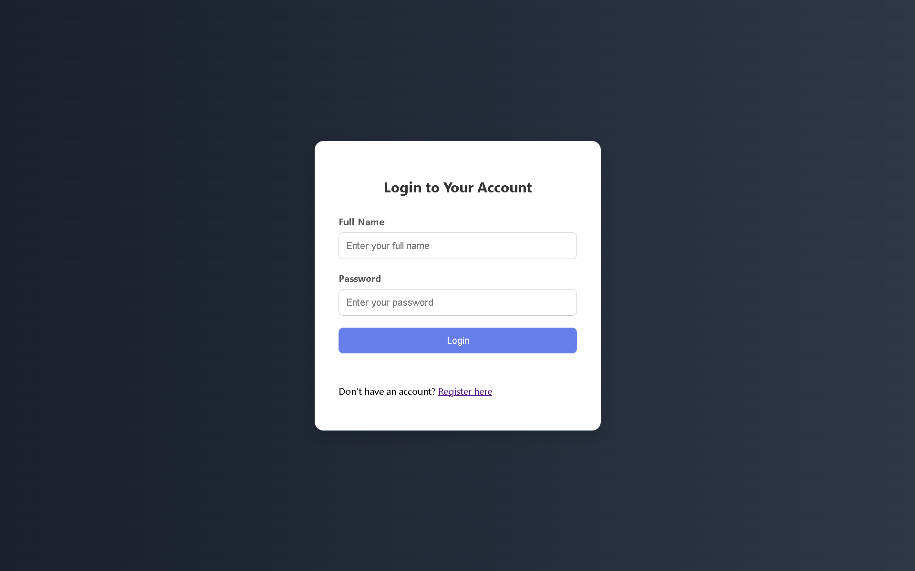

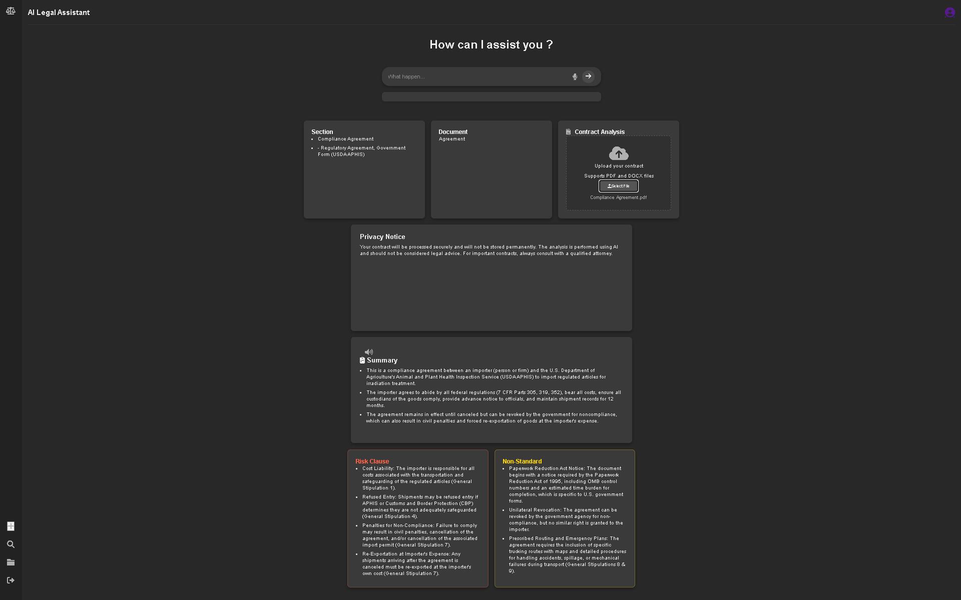

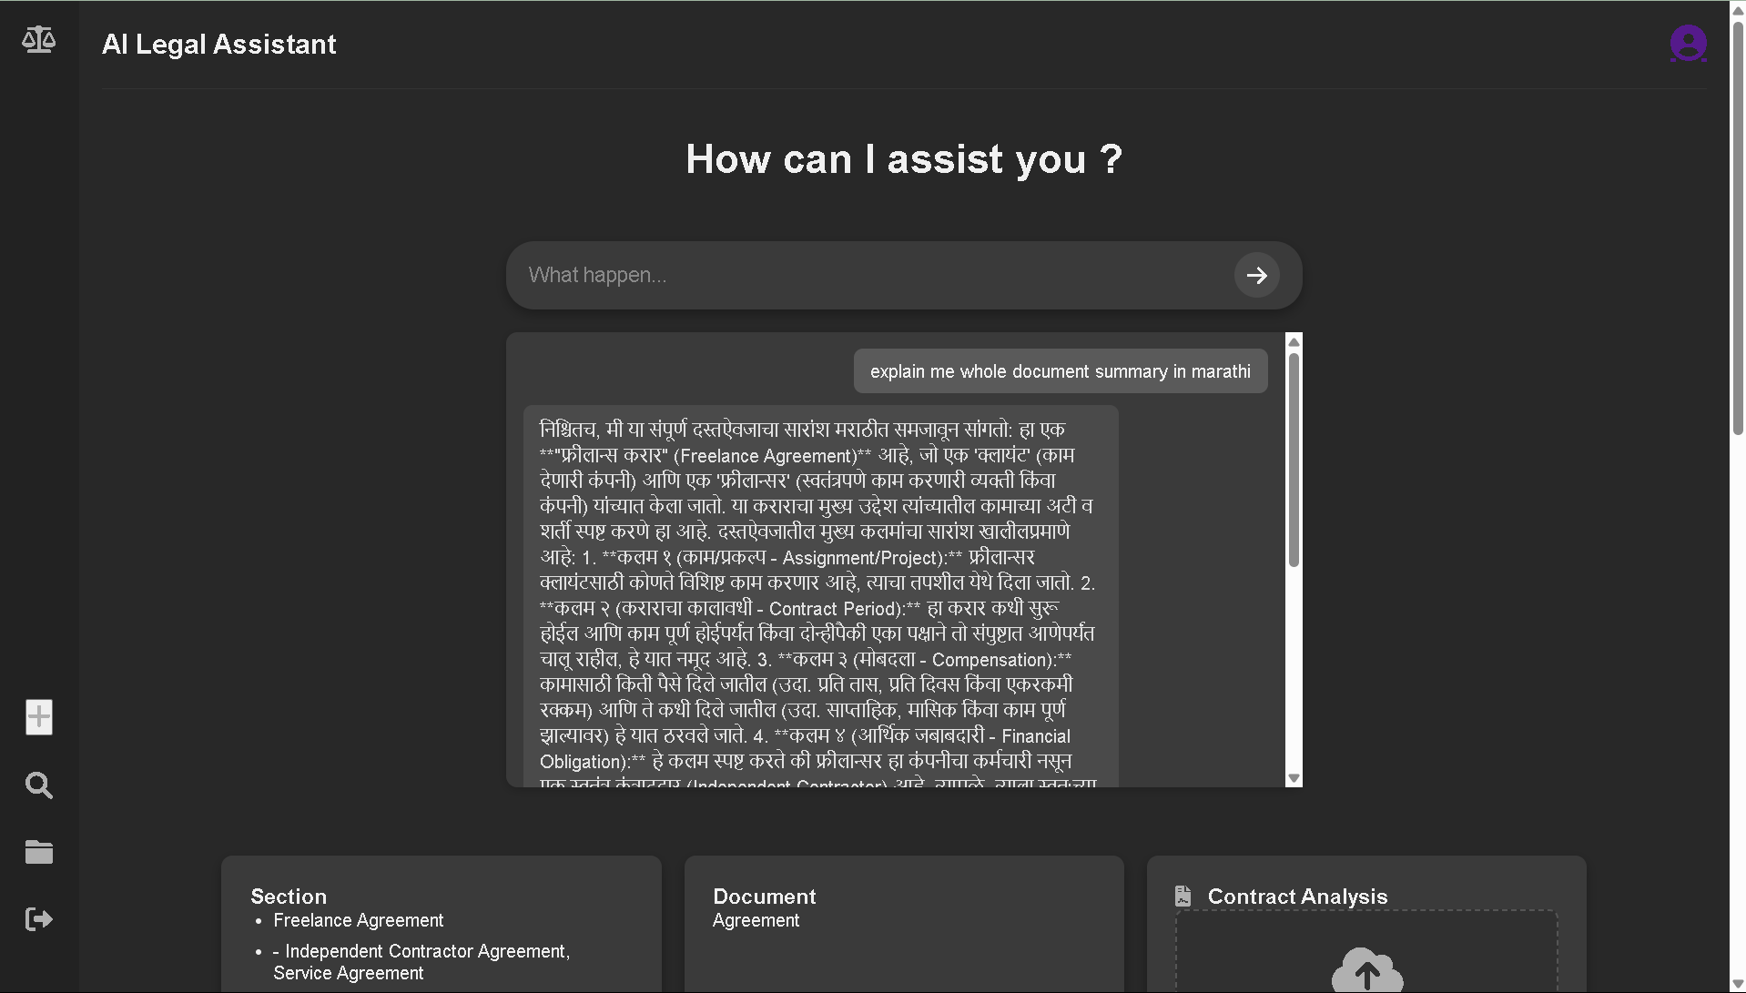

**17. Future Visions –**

**Text-To-Voice & Voice-To-Text**

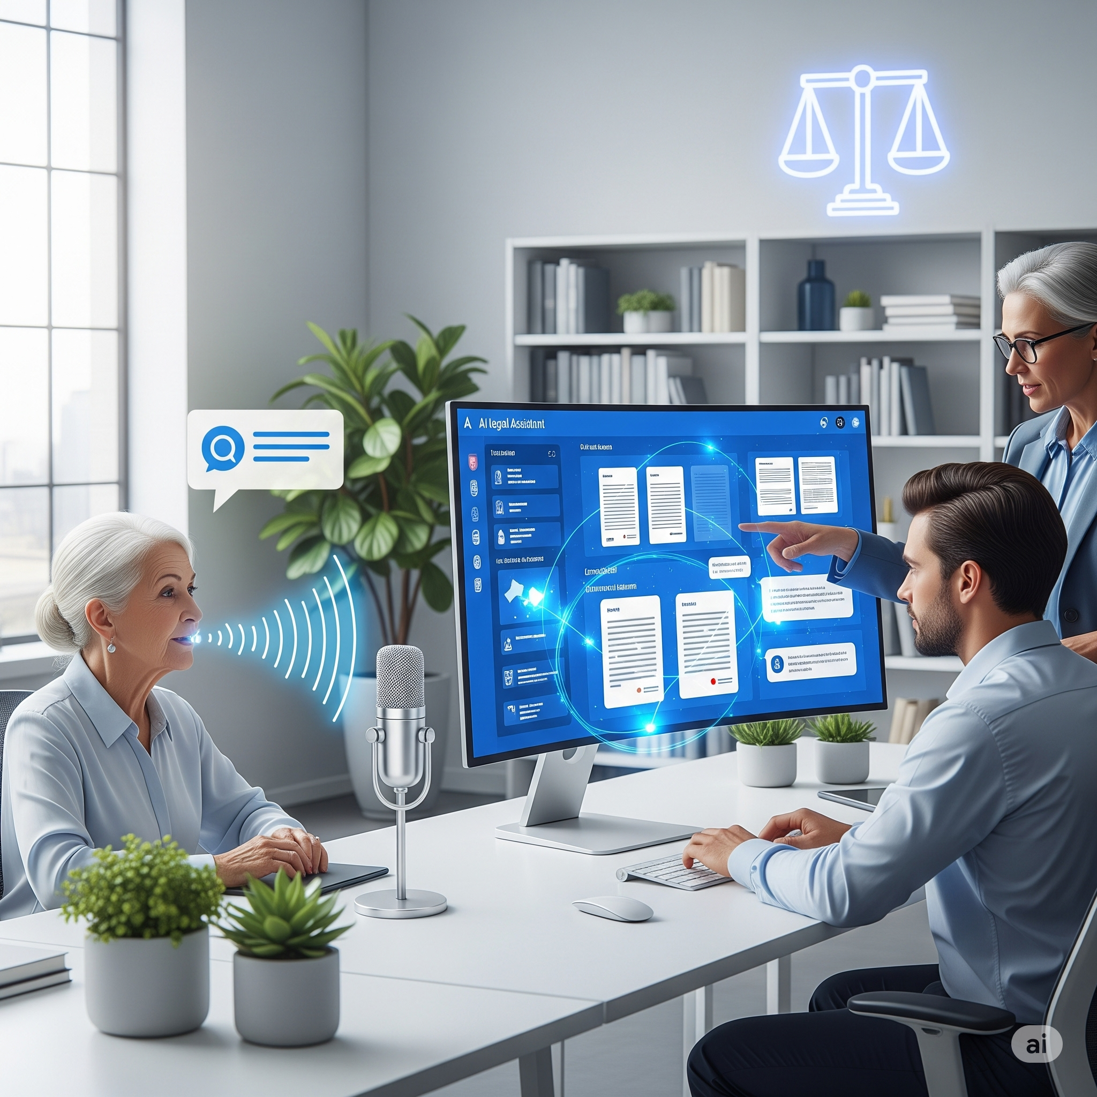

* Implementing **Text-to-Voice** and **Voice-to-Text features** to make the product more accessible for everyday users.

**Identifying Risky Clauses –**

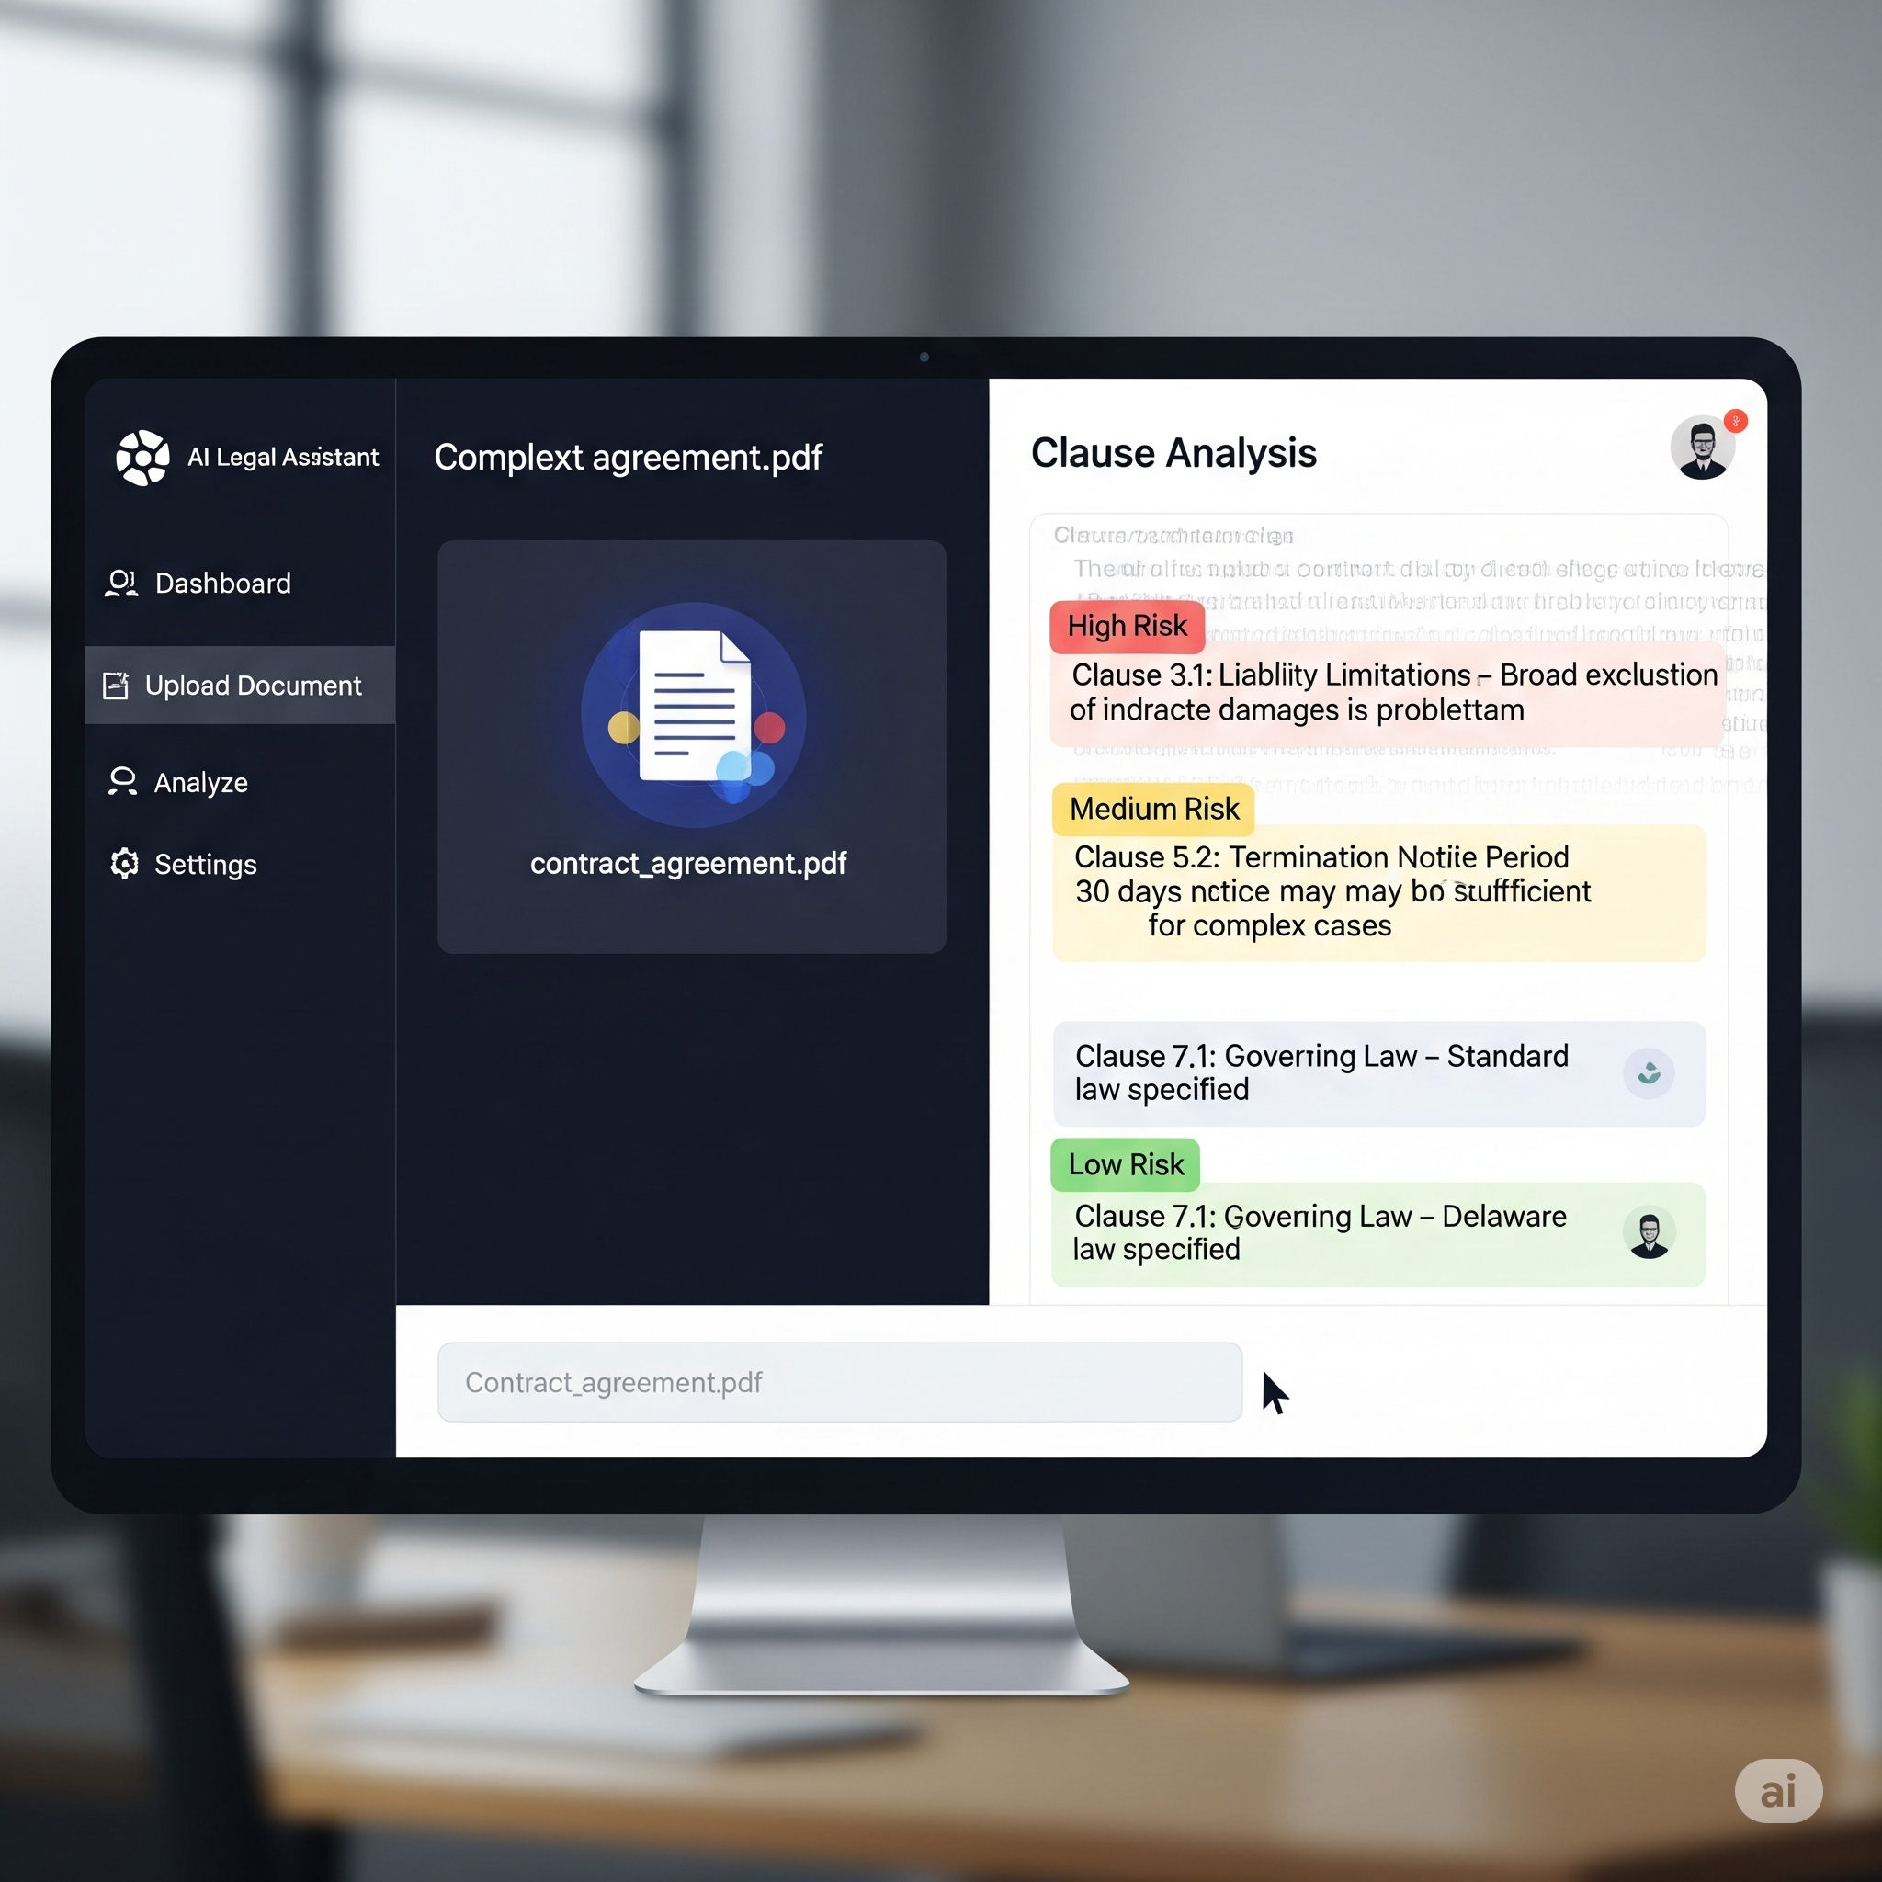

* highlighting them as high, medium, or low risk for better decision-making.

**17. Conclusion –**

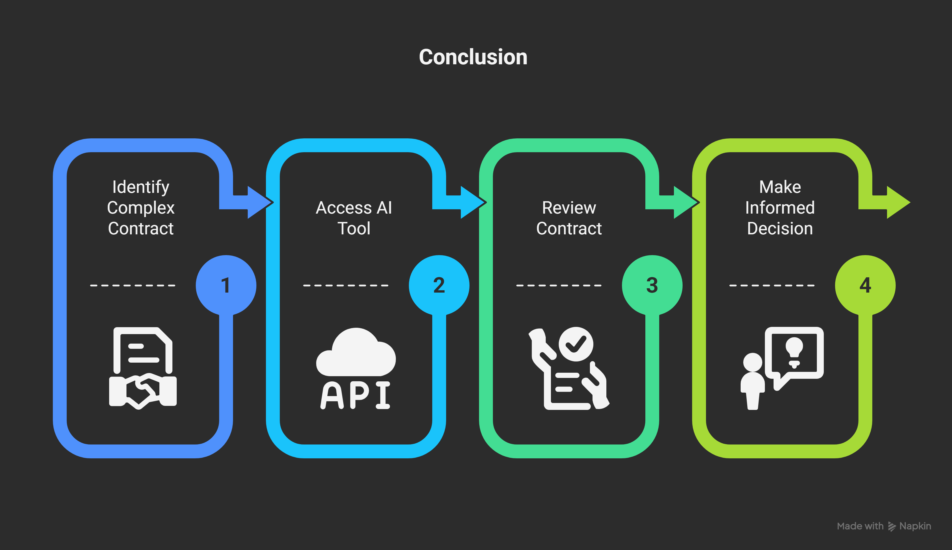

* AI Legal Assistance tools bridge the gap between complex contracts and non-lawyers. Our solution makes contract review accessible, fast, and secure, enabling users to make informed decisions without needing a legal expert every time.